Class | Class No.
c-CS-m | 0
c-SC-m | 1
c-CS-s | 2
c-SC-s | 3
t-CS-m | 4
t-SC-m | 5
t-CS-s | 6
t-SC-s | 7

TSNE PLOT COMPARISON BEFORE AND AFTER FEATURE SELECTION

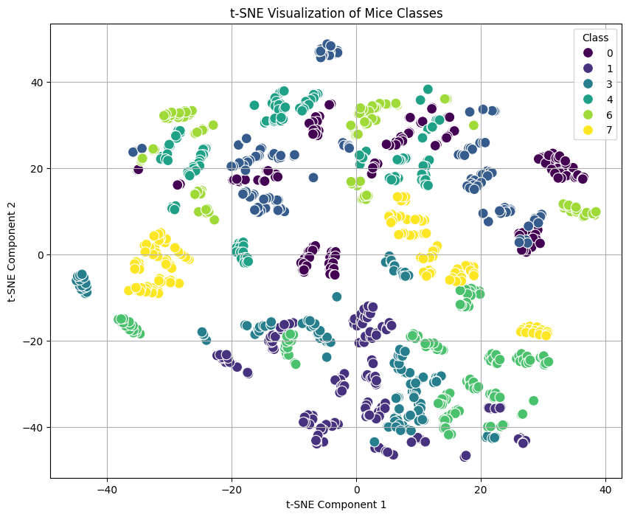
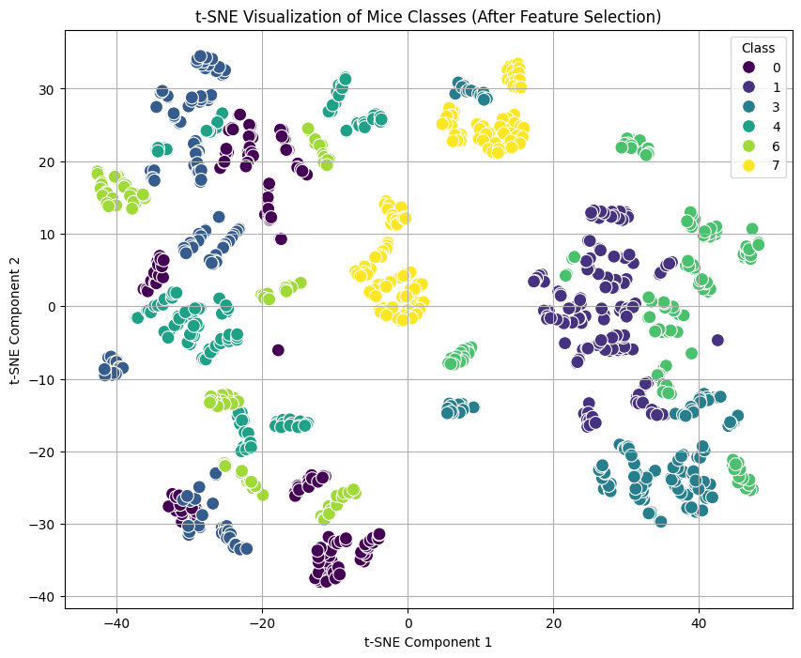

MODEL COMPARISON:
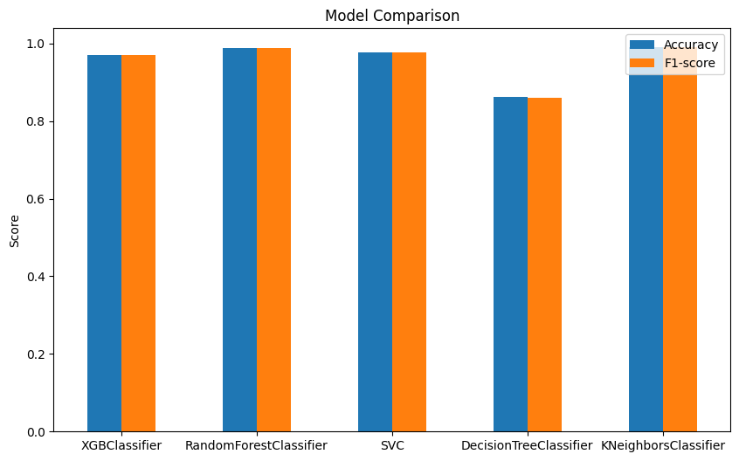

Key Findings:
- Performance Metrics:
- The Random Forest classifier achieves high accuracy and F1-score, comparable to other models like XGBoost and SVC.
- Decision Tree and K-Neighbors classifiers also perform well, but slightly lower than the Random Forest and XGBoost models.
- Model Selection:
- The high performance of the Random Forest classifier validates its suitability for this classification task.
- XGBoost shows the highest accuracy and F1-score, suggesting it might be a better choice if further optimization is pursued.

FEATURE IMPORTANCE REPRESENTATION IN RANDOM FOREST
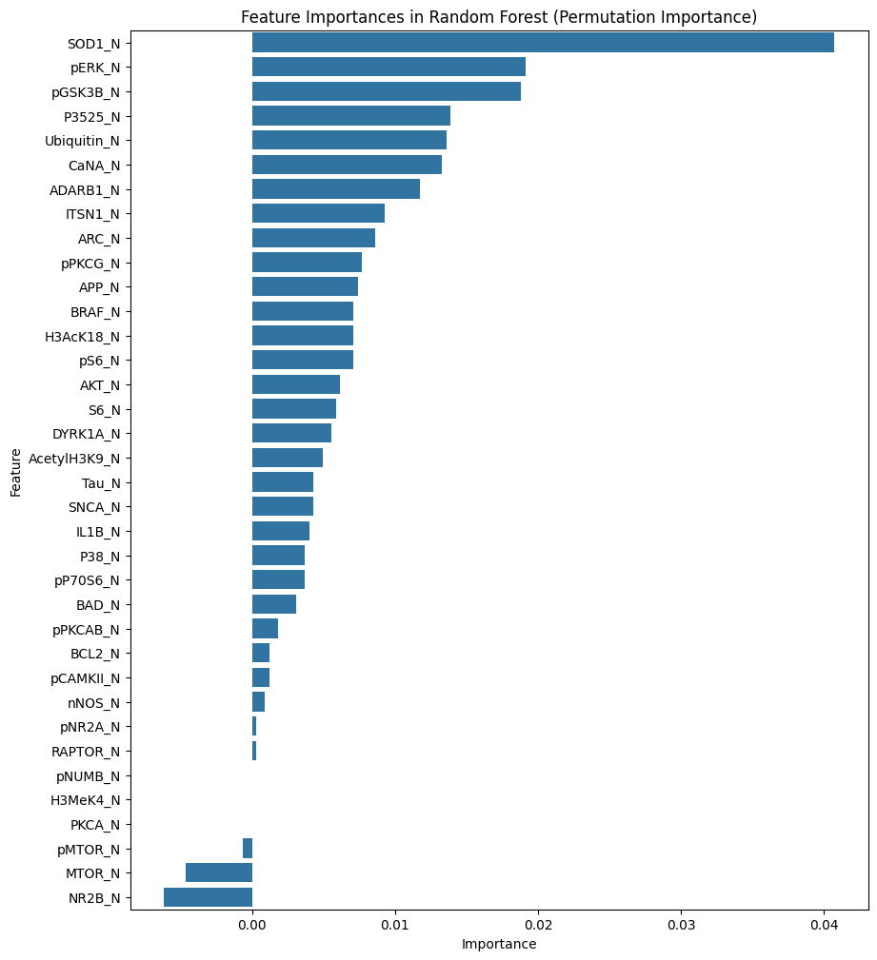

Key Findings:
- Top Important Proteins:
- SOD1_N: The most significant feature, indicating that its expression level is crucial for distinguishing between the different classes of mice.
- pERK_N and pGSK3B_N: Also highly important, suggesting their substantial role in the classification process.
- Other important proteins include P3525_N, Ubiquitin_N, CaNA_N, and ADAR1_N.
- Biological Relevance:
- The identified key proteins are involved in various cellular processes and signaling pathways that could be associated with learning and memory mechanisms, particularly in the context of Down syndrome

CONFUSION MATRIX OF RANDOM FOREST:
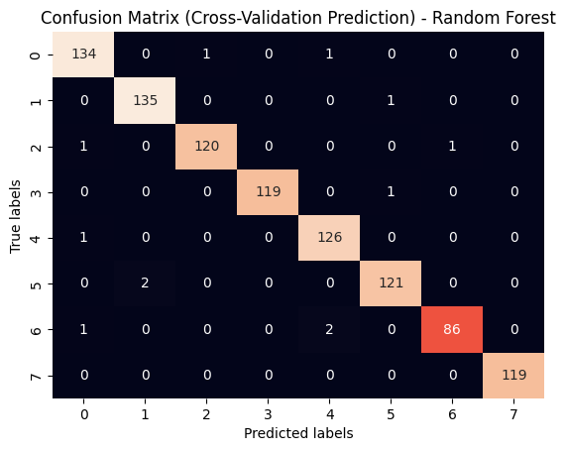

Key Findings:
- Accuracy:
- The model performs well in predicting most classes, as indicated by the high values along the diagonal of the matrix.
- Classes 0, 1, 2, 3, 4, and 5 show high prediction accuracy.
- Misclassifications:
- Class 6 has a notable number of misclassifications, often being predicted as class 5 or 7.
- This indicates a potential overlap or similarity in the protein expression profiles of these classes, suggesting further refinement or additional features might be necessary to improve the classification accuracy.

FEATURE IMPORTANCE REPRESENTATION IN KNN
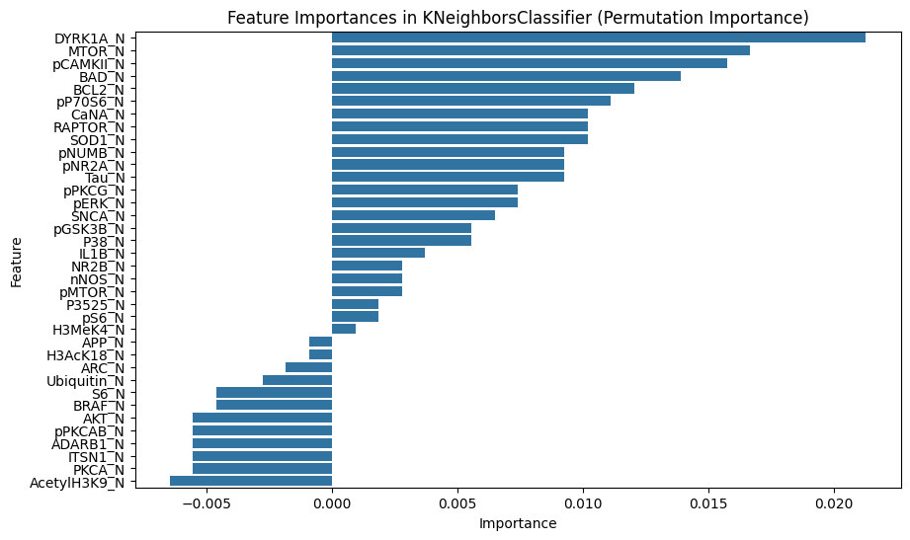

CONFUSION MATRIX IN KNN
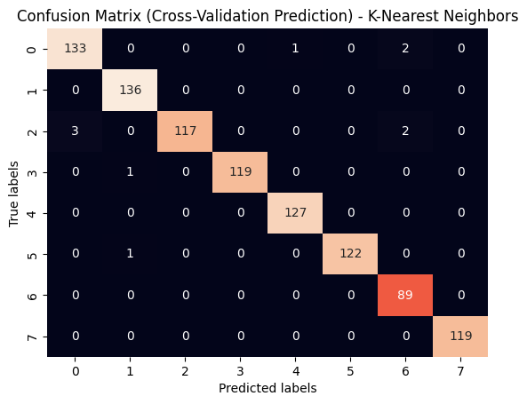

TOP 3 MOST IMPORTANT FEATURES ACROSS ALL MODELS:

